Business Consultant


Fantastic Work on Completing Day 1 & 2! 🎉

You’re off to a strong start, and now it’s time to dive into your customized training schedule—designed to equip you with the skills and strategies needed to excel in the field.

Your Role & Key Objectives

As a Business Consultant, your mission is to onboard merchants and show them how StoreHub can revolutionize their business operations. But persuasion requires skill!

That’s where your training comes in. Over the next few days, you’ll master:

- Effective Pitching – Learn how to confidently present StoreHub’s solutions using prepared slides, highlighting key features and benefits.

- SPIN Selling Methodology – A structured approach to sales that helps merchants connect the dots between their needs and StoreHub’s solutions.

- Closing the Deal – Master the art of securing a commitment on the same day, ensuring merchants see the immediate value of StoreHub.

- Pre-Final Assessment: Sales Simulation – A practice session combining Pitching, SPIN Selling, and Closing, preparing you for real-world conversations.

- Final Mock Assessment – You’ll be given a real-world sales scenario to navigate, assessed by your coach to ensure you’re field-ready.

Your Next 3 Days: Intense, but Worth It!

The next phase of training will challenge you, but the goal is clear: to shape you into one of the best sales professionals at StoreHub.

How it works

📌 Follow Your Schedule: Stick to the assigned time slots and topics to stay on track.

📌 Accessing Your Resources: For each topic, make sure to check out the resources provided under your role-specific tabs in the Training Wiki. These materials are your go-to guides to master the skills and knowledge required.

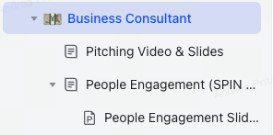
Expand the drop-down Business Consultant

📌 Block your coach's Calendar: Keep an eye out for the [BC TL] Review Sessions in your schedule. Total 5 review sessions, ensure these sessions happen as planned. You’re required to send invitations for all [BC TL] Review Sessions to your coach:

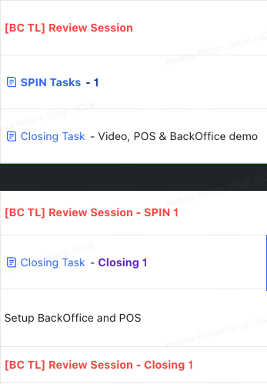

Missing this step can disrupt your entire training timeline—so don’t skip it!
📌 Leverage Your Resources: Use the provided materials, case studies, and expert insights to enhance your learning.

This is your moment to sharpen your skills, build confidence, and become an expert at selling StoreHub!

Your Schedule

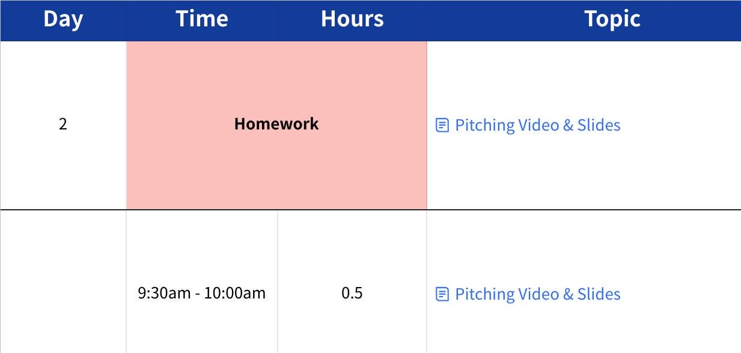
Click the image to view the sheet.

Important Note About Your Schedule 🗓️

At times, your schedule may change based on your coach’s requests. Please stay alert and keep track of any updates or adjustments made to the schedule.

Make sure to accommodate these changes promptly to stay on track with your training goals. Flexibility is key—stay adaptable, and you’ll do great! 🚀

Stay proactive, organized, and focused, and you’ll ace this next phase of your training journey. Good luck! 💼✨

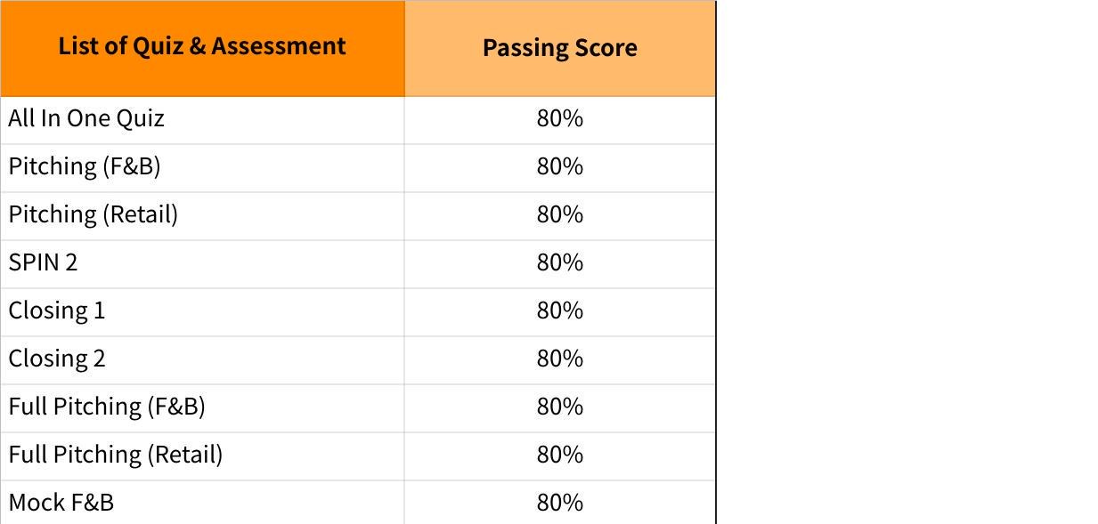
Click the image to view the sheet.

